Session 2026-2027

Vision:Dream of where you want. | Mission: Means to achieve Vision

Program Educational Objectives of the program (PEO): (broad statements that describe the professional and career accomplishments)
PEO1 | Preparation | P: Preparation | Pep-CL abbreviation  pronounce as Pep-si-lL easy to recall
PEO2 | Core Competence | E: Environment (Learning Environment)
PEO3 | Breadth | P: Professionalism
PEO4 | Professionalism | C: Core Competence
PEO5 | Learning Environment | L: Breadth (Learning in diverse areas)

Program Outcomes (PO): (statements that describe what a student should be able to do and know by the end of a program)
Keywords of POs:
Engineering knowledge,Problem analysis, Design/development of solutions,Conduct Investigations of Complex Problems, Engineering Tool Usage, The Engineer and The World,Ethics, Individual and Collaborative Team work,Communication, Project Management and Finance, Life-Long Learning

PSO Keywords: Cutting edge technologies, Research

“I am an engineer, and I know how to apply engineering knowledge to investigate, analyse and design solutions to complex problems using tools for entire world following all ethics in a collaborative way with proper management skills throughout my life.” to contribute to the development of cutting-edge technologies and Research.

Integrity: I will adhere to the Laboratory Code of Conduct and ethics in its entirety.

Name and Signature of Student and Date
(Signature and Date in Handwritten)

Session | 2026-27 (ODD) |  | Course Name | Web Technology Lab
Semester | 3 |  | Course Code | 23CT1301
Roll No | 67 |  | Name of Student | Sumit Jadhao
Practical Number |  | 3
Course Outcome |  | - Understand various internet technologies.  - Design the web pages using HTML and CSS.  - Implement the XML technology to store the data.  - Develop the interactive web pages using JavaScript.
Aim |  | To develop and demonstrate the usage of inline, internal, and external style sheets using CSS.
Problem Definition |  | To understand different methods of applying CSS to an HTML document and demonstrate inline CSS, internal CSS, and external CSS by creating simple web pages.
Theory  (100 words) |  | CSS stands for Cascading Style Sheets. It is used to control the appearance and layout of HTML web pages. CSS can change properties such as text color, background color, font size, spacing, borders, and alignment. There are three main ways to apply CSS in HTML. Inline CSS is written directly inside an HTML element using the style attribute. Internal CSS is written inside the <style> tag in the <head> section. External CSS is written in a separate .css file and connected to HTML using the <link> tag. External CSS is useful when the same design is used on multiple pages.
Procedure and Execution  (100 Words) |  | Step for Implementation:  - Open a text editor such as VS Code or Notepad.  - Create an HTML file and save it as index.html.  - Apply inline CSS using the style attribute inside an HTML tag.  - Add internal CSS using the <style> tag inside the <head> section.  - Create a separate file named style.css for external CSS.  - Connect the external CSS file using the <link> tag.  - Add headings, paragraphs, and buttons to the webpage.  - Apply different styles using all three CSS methods.  - Save both HTML and CSS files.  - Open the HTML file in a web browser and observe the output.
Code:

HTML File – index.html

<!DOCTYPE html>
<html>

<head>
<title>CSS Example</title>

<link rel="stylesheet" href="style.css">

<style>
h2 {
color: green;
text-align: center;
}

.internal {
background-color: lightgray;
padding: 10px;
}
</style>

</head>

<body>

<h1 style="color: blue;">Inline CSS Example</h1>

<p style="font-size: 18px;">
This paragraph is styled using inline CSS.
</p>

<h2>Internal CSS Example</h2>

<p class="internal">
This paragraph is styled using internal CSS.
</p>

<h3>External CSS Example</h3>

<p class="external">
This paragraph is styled using external CSS.
</p>

<button>Click Me</button>

</body>

</html>

External CSS File – style.css

h3 {
color: purple;
}

.external {
background-color: lightyellow;
font-size: 18px;
}

button {
background-color: black;
color: white;
padding: 8px;
}
Output:

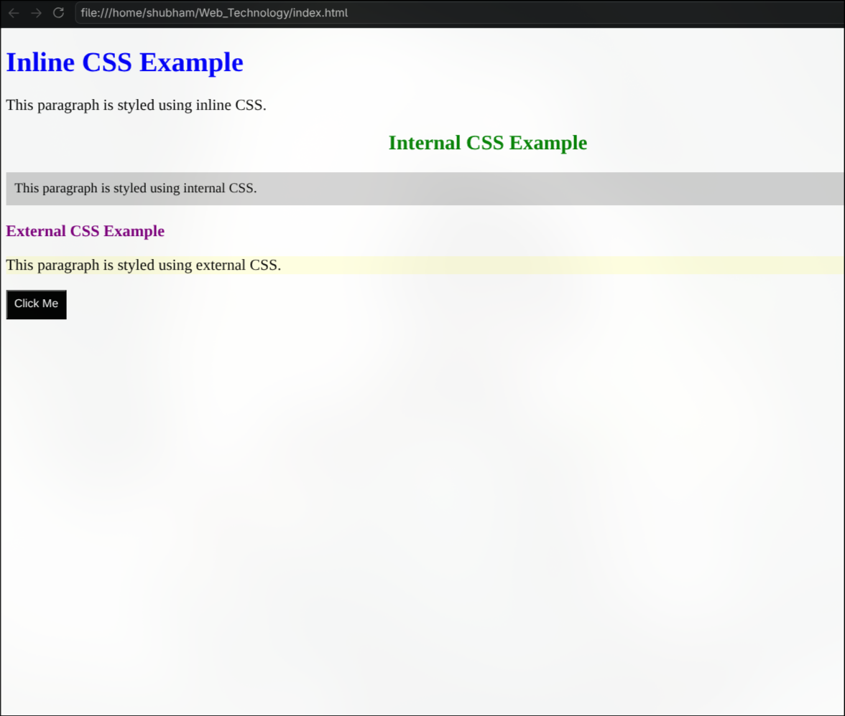
Output Analysis |  | The webpage was successfully displayed in the browser with different CSS styles. The first heading and paragraph were styled using inline CSS. The second heading and paragraph were styled using internal CSS defined inside the <style> tag. The third heading, paragraph, and button were styled using the external style.css file. This demonstrates that CSS can be applied to HTML using three different methods.
Link of student Github profile where lab assignment has been uploaded |  | https://github.com/Sumit0745
Conclusion |  | The webpage was successfully displayed in the browser with different CSS styles. The first heading and paragraph were styled using inline CSS. The second heading and paragraph were styled using internal CSS defined inside the <style> tag. The third heading, paragraph, and button were styled using the external style.css file. This demonstrates that CSS can be applied to HTML using three different methods.
Plag Report (Similarity index < 12%)
Date |  | 21/07/2026

